Project Title: Pyroelectric Infrared Sensor
Link: https://wiki.microduino.cc/index.php/Pyroelectric_Infrared_Sensor

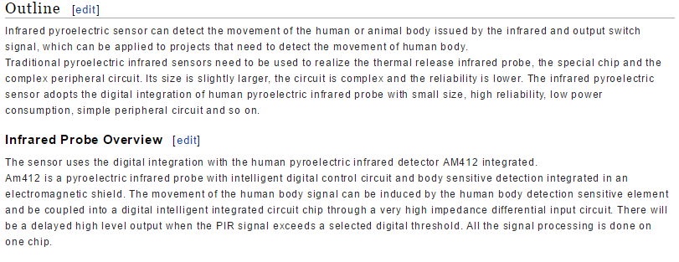
ORIGINAL:
Infrared pyroelectric sensor can detect the movement of the human or animal body issued by the infrared and output switch signal, which can be applied to projects that need to detect the movement of human body.
Traditional pyroelectric infrared sensors need to be used to realize the thermal release infrared probe, the special chip and the complex peripheral circuit. Its size is slightly larger, the circuit is complex and the reliability is lower. The infrared pyroelectric sensor adopts the digital integration of human pyroelectric infrared probe with small size, high reliability, low power consumption, simple peripheral circuit and so on.
Infrared Probe Overview
The sensor uses the digital integration with the human pyroelectric infrared detector AM412 integrated.
Am412 is a pyroelectric infrared probe with intelligent digital control circuit and body sensitive detection integrated in an electromagnetic shield. The movement of the human body signal can be induced by the human body detection sensitive element and be coupled into a digital intelligent integrated circuit chip through a very high impedance differential input circuit. There will be a delayed high level output when the PIR signal exceeds a selected digital threshold. All the signal processing is done on one chip.

EDIT:
The Pyroelectric Infrared Sensor can detect changes in heat in an area. PIR is commonly used to detect the movement of people.
PIR sensors use an infrared probe to passively detect ambient heat over an area with a given range. The Microduino PIR sensor integrates a small processor and a small, highly reliable probe (the AM412) into our standard interface to add PIR sensing to any Microduino project.
It should be noted that there will be a delayed high level output when the PIR signal exceeds a selected digital threshold. All the signal processing is done on one chip.

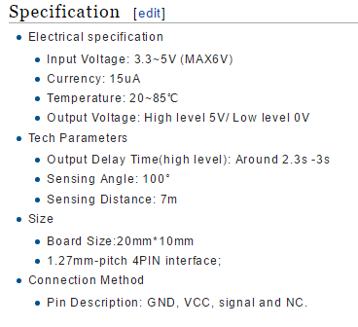
ORIGINAL:
- Electrical specification
  - Input Voltage: 3.3~5V (MAX6V)
  - Currency: 15uA
  - Temperature: 20~85℃
  - Output Voltage: High level 5V/ Low level 0V
- Tech Parameters
  - Output Delay Time(high level): Around 2.3s -3s
  - Sensing Angle: 100°
  - Sensing Distance: 7m
- Size
  - Board Size:20mm*10mm
  - 1.27mm-pitch 4PIN interface;
- Connection Method
  - Pin Description: GND, VCC, signal and NC.

EDIT:
- Electrical Specifications
  - Input Voltage: 3.3~5V (MAX6V)
  - Current: 15uA
  - Temperature: 20~85℃
  - Output Voltage: High level 5V/ Low level 0V (Digital Output)
- Technical Specifications
  - Output Delay Time: ~2.3-3 seconds
  - Sensing Angle: 100°
  - Sensing Distance: 7m
- Dimensions
  - Board: 20mm*10mm
  - Interface: 4-Pin, 1.27mm pitch
- Interface
  - Pins: Signal, VCC (power), GND (ground) and NC (not connected).

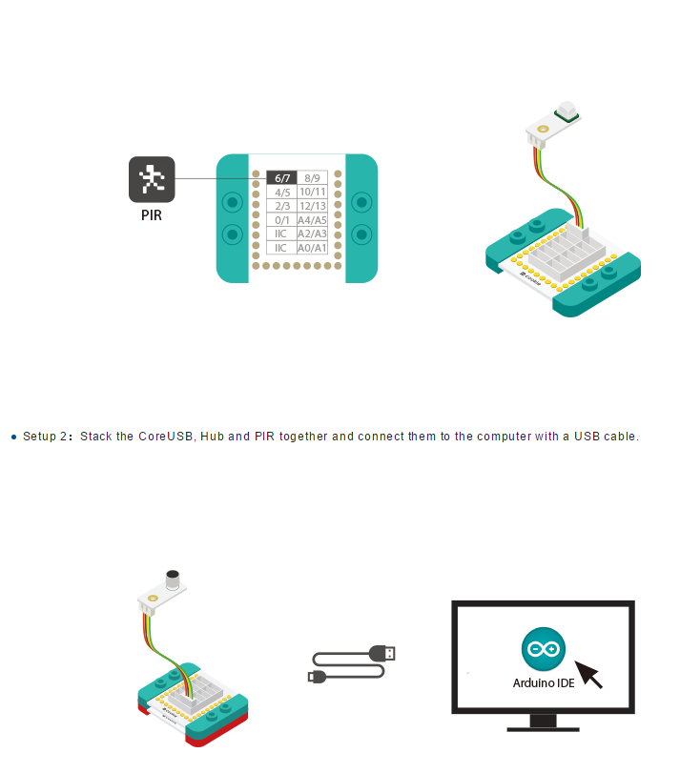

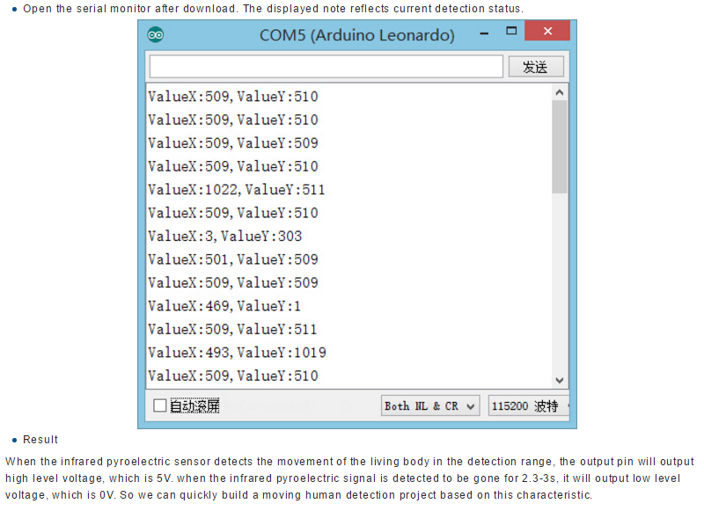
ORIGINAL:
When the infrared pyroelectric sensor detects the movement of the living body in the detection range, the output pin will output high level voltage, which is 5V. when the infrared pyroelectric signal is detected to be gone for 2.3-3s, it will output low level voltage, which is 0V. So we can quickly build a moving human detection project based on this characteristic.
EDIT:
The PIR sensor outputs a purely digital signal (i.e. either HIGH/LOW). When the sensor detects movement, the output from the sensor will be HIGH (5V). The signal will linger once movement has stopped, for about 2.3-3s. The sensor will output a LOW signal (0V) when there is no movement.

